West Hull Ladies
RRC

November Newsletter

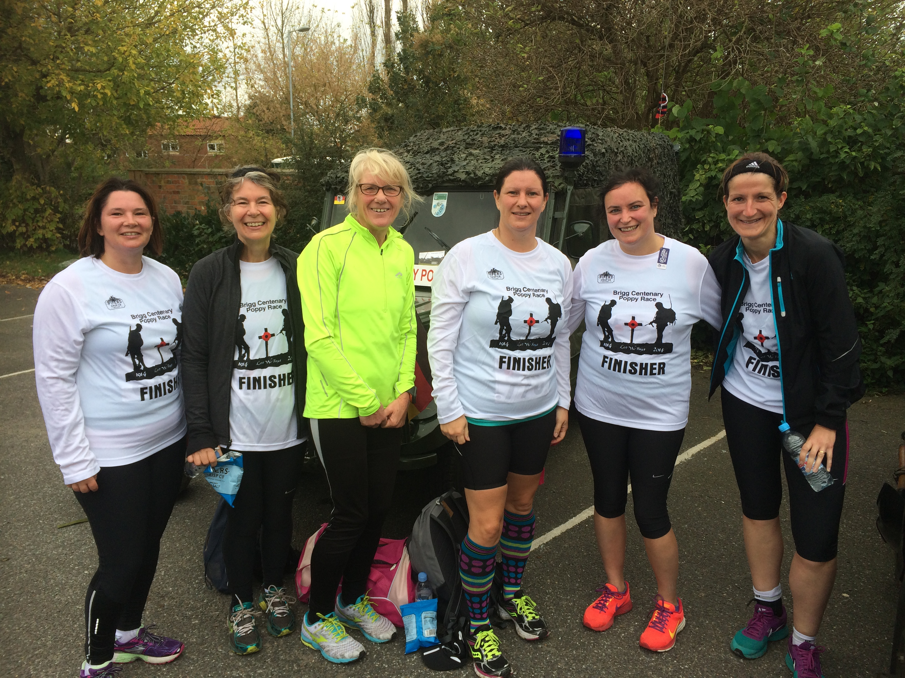

Brigg 10k 26th October 2014

West Hull Ladies

WEST HULL LADIES RRC COMMITTEE MEETING
Committee Meeting 3rd November 2014

Minutes
Present - Jill, Karen, Sandra, Maria, Rachael L, Zoe, Amanda, Sara K

- Apologies received from Hayley, Linda, Annette,
- Minutes of previous meeting accepted as an accurate record
- No update as yet from Hayley about proposed food seminar. Action Hayley to update next meeting. No email sent to Club members about any interest for training as officials Action Jill to send out email. Sara and Debbie were to hold track session on Friday 7th Nov, email had gone out. The email concerning updating Annette about any 10ks run had also gone out.
- We had been invited to enter competition to find Club of the Year. Brain storming session held to list why we were worthy of winning this. Action Sandra to prepare entry and then pass to other members for any other additions /amendments.
- Discussion about relay teams for the Hull Marathon 2015. Suggested Anna to act as co-ordinator for all teams. Action Amanda to ask Anna if she was happy to do this and if so email to all ladies asking them to keep Anna informed.
- Discussed when we would like workshops on offer from Heidi. Decision made for December for foam rolling, 1st week in Feb for injury prevention and psychology in March. Action Amanda to inform Heidi.
- Discussion about the kit, which we were running low on. Agreed that the new vests hadn’t been as good as previous and maybe we should try to find different supplier. Action Rachael to contact Runnercare and make enquires re any kit they could provide.
- Discussion about possibility of maps of runs being available for new ladies either on FB or website. Action Amanda to circulate routes (this has been completed via email)
- Ladies agreed that the Club should again organise a 0-5k course starting January 5th. Leaders needed for the 6 week course, Amanda could do the Monday, Maria and Sandra the Wednesday and Jill Friday. More ladies would be needed to help with this. A discussion then centred around starting the buddy system again on a Friday evening. It was agreed that we would try and implement this again and ask for volunteers. Action Amanda to send out email.
- Tracy had asked about the possibility of holding Marathon workshops. This was seen as a wonderful idea and would take place later in the year before Ladies started preparations for the Hull Marathon.
- Rachael informed the committee that the sale of the YPI would be completed this Friday and the new owners were to be Latus. They would hold talks with us after the sale. Rachael said HumberRunner were happy to hold another evening for Ladies who wished to have their running gait analysed. Action Rachael to send out email for expressions of interest and to organise date for this to take place. Amanda asked for the Club to buy more stopwatches for LiRFs. Action - more stopwatches to be bought. Jill spoke about the criteria for members being allowed in the club ballot for London marathon places. It was felt that all members should be consulted on how they thought this should be done, Action Jill to contact Ladies asking for their views in relation to this. Jill then updated the Committee about entries to Thunderun. It had been a harrowing experience to say the least to try and get teams in. For the Thunderun we had 1 solo, 1 pair and a team of 5. We also had a team of 5 and a team of 3 entered for the Enduro run which takes place in June.

Training Advice – Amanda (CiRF)

General
The most important thing you should do is enjoy your running.
Stay healthy and injury free. Cannot always guarantee this but you can do a lot to help: adopt a good running style*, do some core body strengthening, stretch, eat well and get enough rest. Know your body and know when to rest, deal with injuries/niggles, don’t ignore them. Learn what is best for you.
Keep motivated: Set yourselves targets, try different races, join team events, challenge yourself. Get a PB. Win a prize

Beginners: The most important part of running is to build a good base and remain injury free. The base is your weekly mileage. I suggest you progress as follows:
- Keep up 3 runs a week. When you reach 12 miles a week join the Friday Thresholds. These are an ideal introduction to speed work as the efforts are just 30 seconds and should not put too much strain on your joints. They are fun and a great start to the weekend. By now your long run will be heading towards 5 miles.
- Next progress to 15 miles a week over 3-4 runs with 6miles/10K as your longest run and now you are ready to join the Monday speed work sessions. Some of these are much more prolonged efforts but don’t be deterred – it is at your pace.
- Over the coming year I would recommend you restrict yourselves to 10K races but build your social runs up to 10 miles. Get yourself into the Hull Marathon Relay
Speeding up your 10K races: You’ve done a 10K and want to get better? I was told you will only get your best 10K when you are capable of running 10 miles so if not there yet, build up to 10 mile social runs. Your base is important, make sure you are doing at least 15 miles each week and running at least 3 times. Include 2 quality (speed work) runs each week. My best improvements came about on long repetitions e.g. Mile or Kilometre reps. You can add a mile effort into your longer run if not able to get to the speed work sessions.

Half Marathon: The best way to get your target is to find a training plan aimed at what you hope for. E.g. google ‘Half Marathon Training Sub 2 hours’. If you are not sure of what you could achieve then be optimistic, go for a faster training plan. If after a couple of weeks it is too tough switch to an easier on. When you find one, adapt it to your life style, although the way it says to train might be the most ideal it is no use saying Thursday for a 5 mile run when that is the night you take the kids to swim class. So if it says speed work on Tuesday, switch to Monday to be with the girls. If the long run is Sunday and you prefer Saturday – change it. If it says reps 400M x 8 and you think “eh?” then change to 2 min reps x 8 – because you can time that. In general, expect to find a weekly mileage of 25+ miles with 2 quality sessions.

Marathon: Basically the same advice as the Half Marathon, find a training plan however, I would advise that you are used to running 25 miles a week before you start marathon training. Ask the club marathon ladies about the training schedules they have followed and if they have worked. In general your weekly mileage will be at least 30 miles and go over 40 miles at the peak and will include at least 2 quality sessions each week and some running at your target marathon pace.

Enjoy your running and be proud of all your achievements.

*Running Style: In the past I have carried out a running style coaching session once a month but the interest dwindled. However, I intend to get one together before Christmas and hope everyone who has not been to one will make the effort to come along. You will learn a lot which will help you run more efficiently and make it less likely you will become injured.

Leg it around LathKil - Amanda

I was away this weekend in Derbyshire and my Bingley Harrier fell running friends Becky (no 87) and Gordon (no 88) had found this race and it looked good. 7.1 miles so not an epic. Len (no 86) joined in too.

It was a lovely run on a beautiful day. We set off down through the village, way too many runners for the narrow streets and could not really get going. Then there was a very slippery bend before we headed onto the footpath along the river. This was lovely but again slippery mud and limestone underfoot and narrow so difficult to pass people. We then headed up a steep hill which had steps for half of it. I passed a couple of people on that. Then over the tops and across fields with wonderful views. Then back down to the river (in the other direction) for about a mile before a very steep climb, really pleased to again pass some runners. It eased up and we were into the final field to the finish funnel. I was pleased with my time 63 minutes and came 4th in the FV50 group (10 year categories).

I really enjoyed it and felt strong throughout and am certain would have done better if I had started nearer the front but was really pleased to be out in gorgeous countryside and enjoying running.

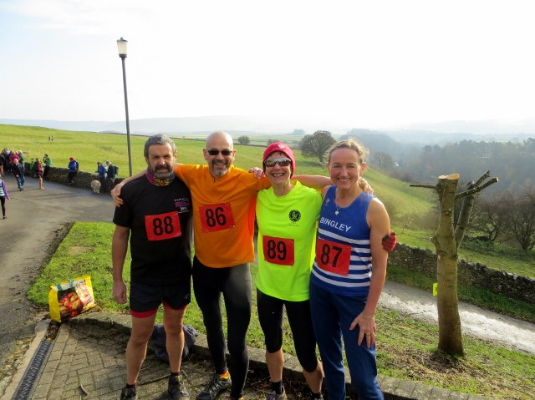

Note on Fell Races: There are rules for anyone considering a fell race. On this race because of the good weather and not going high up we did not need to carry anything, however, normally you would be expected to carry full waterproofs (with taped seams), map, compass, whistle and spare food.

I joined Jane, Trish, Marie, Karen & Sandra at the Brigg 10k Poppy Race and what a fabulous race it was! Very well organised, great atmosphere and the best marshals I’ve experienced in a race!

Brigg 10k – Hayley

The weather was a little on the blustery side but other than that was ok. The route was an out & back along a country road with a little incline up to the turning point down a farm track.

I was a little nervous about this race as it was my first since March but once I got going I couldn’t help but enjoy. An ‘older’ gentleman from a Scunthorpe club befriended me from the start and offered to be my windshield during the head wind outward run, I’m afraid I wasn’t very talkative but that didn’t seem to put him off from giving me plenty of tips – all of which were very appreciated! Once we hit mile 2, ‘my friend’ wished me luck, mentioned I’d likely finish around 65 mins and then notched it up a gear and left me to ponder his running tips whilst he shared his wealth of experience with various runners in the distance.

I don’t know about anyone else, but I have always disliked the first 12 mins of any run but once past this, then generally I know whether I’m in for a good or bad one! Thankfully this was going to be a good one for me, approaching mile 4 I felt strong (even with the wind and incline) and I was happy that I was running a comfortable pace. I could see Jane, Karen & Marie in the distance but I had no desire to even attempt to run a little faster to see if I could get nearer to them, my aim of the day was to enjoy the run and not be the last over the finish line! I’m still waiting for my competitive streak to make an appearance but until then I’ll stick with not being last!

As I hit the last mile I began to tire and just I was thinking of taking my foot of the gas, Sandra’s beaming smile interrupted my thoughts and shook me out of my daydream yelling ‘come on last mile, get a sprint on’…. I have to say sprinting was the last thing on my mind but nevertheless I dug deep and upped my pace very slightly. The last ¼ mile was a killer but as I rounded the corner searching for the finish line I spotted Karen and then finally got over the finish line were I think my first words to Jane were ‘I’m gonna be sick’ thankfully I wasn’t!

The marshals along the whole route were very animated and encouraging and I especially appreciated the sounds of Donna Summers “Hot Stuff” blaring out half way along the route, could’ve done with this at mile 6 too!

This was my first 10k race in a good few years (not the plan for this year but injury put paid to my earlier race plans!) and I didn’t really know what kind of time I was aiming for, I’m not really a time focussed runner but I was pleased with my 65:56 mins time – I’ll secretly aim to beat it next time!

The post race goodies were nice – homemade flapjack & pipers crisps and a long sleeved running top – what more could a girl want on a blustery October morning!

Recipes & Nutrition

Sultana & Apple Cake - Ros

Ingredients
3oz (75g) Butter
4oz (100g) Caster sugar
2 eggs
8oz (200g) Self raising flour
300ml Greek yoghurt - full fat
Handful of sultanas
1 Large bramley apple (peeled, cored and chopped)
1 teaspoon of nutmeg

Method
Pre-heat the oven to 180c (fan assisted)/ gas mark 6. Line your baking tin (20cm sq) with baking parchment.
Cream together butter and caster sugar.
Add the eggs and mix together.

Add the yogurt and mix together.

Add the flour and stir until it's combined.

Stir in the sultanas, chopped apple and nutmeg.

Tip the mixture into your prepared baking tin.

Set the timer for 30 minutes. You may need to turn the temperature down and bake for a further 5-10 minutes as the yoghurt makes it a very moist cake.

Races

Racing and Running Events
Fancy something different? For worldwide marathons click here

Date/Time | Event | Fee | Entry forms | Online entry
December 2014
6th/08:30 | Rudolph's Romp | £10 | Entry form | Postal entries only

Please remember to double check dates, times and entry fees with the official website or the entry form.

www.westhullladies.org.uk/races.htm Zoe, Racing Officer

NOTE: Club Vests must be worn at any races you enter
under the West Hull Ladies running club name.

West Hull Ladies Road Running Club
Kit Order Form

FORENAME ___________________________________

SURNAME ___________________________________

ORDER - tick what you require, with size Price

- VEST SIZE ___________ £16.00
- LONG SLEEVE TOP SIZE ___________ £18.50
- BEANIE HAT £6.50
DATE Ordered _______________

AMOUNT PAID _______________

Please transfer payments online with your name and marked as ‘Kit’ to:
Account: 63762742 Sort Code: 20 43 49.
Or cheque payable to ‘West Hull Ladies RRC’, and write your name and ‘Kit’ on the back and give to Club Treasurer Debbie Watson, 51 Westbourne Ave, Hull.

Sign on receipt of goods _________________________________

DATE _______________

Please complete this form and email to diazmaria@btinternet.com

Thanks.
Maria
Kit Officer

